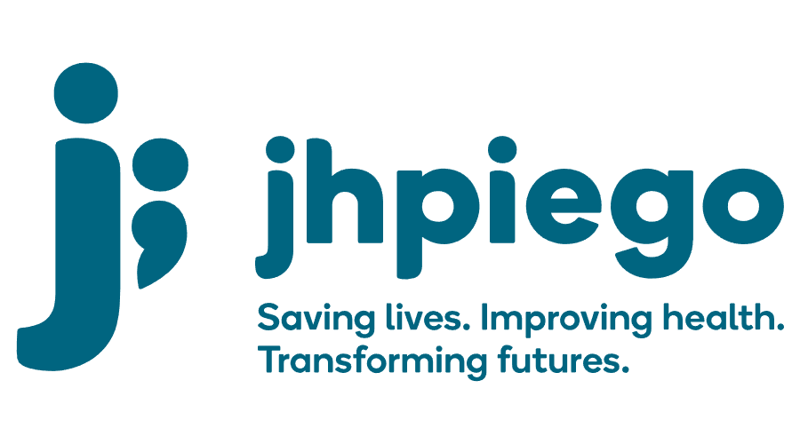

Jhpiego is an international, non-profit health organization affiliated with The Johns Hopkins University. For 40 years and in over 155 countries, Jhpiego has worked to prevent the needless deaths of women and their families.

Jhpiego Corporation has been providing technical support to the Ministries of Health in partner countries across the globe for the past 40 years in a variety of technical areas including cervical cancer treatment and prevention, community health, HIV and AIDS, maternal and newborn health, health workforce capacity development (both pre-service and in-service), family planning, malaria, and IPC/WASH.

The Global Reach II project is a five-year global HRSA-funded project, which started in October, 2021. It employs an iterative approach based on a country’s needs, informed by clients and beneficiaries, targeting high-priority populations and low-coverage and poor-performing areas to achieve HIV epidemic control. In Sierra Leone, Global Reach II works with government and builds local capacity to identify and implement proven solutions where they exist and develop innovative solutions to overcome persistent barriers that affect HIV services. Global Reach II will develop the capacity of the interdisciplinary health workforce to provide quality, client-centered care, ensuring that individuals will be informed and empowered to access services, receive high-quality care, adhere to treatment and remain in care, ultimately contributing to achievement of HIV epidemic control in Sierra Leone.

The following vacant position is available for immediate filling:

Human Resource (HR) Manager

Position Reports to: Country Program Manager
Job Location: Freetown

Job Summary

The Human Resource (HR) Manager is responsible for implementing and maintaining HR systems and ensuring compliance with organisational policies, procedures and donor regulations.

Policy and Procedures
- Provide oversight to compliance with policies and procedures outlined in the Jhpiego HR manual
- Consult with lawyer to ensure compliance with Labour Laws

JEMS
- Establish and maintain personal records for all staff on the Jhpiego Enterprise Management System (JEMS)
- Ensure high quality administration of the JEMS system including, adding new staff members, updating holidays and supporting the addition of new modules and functions and training staff to utilize them
- Provide regular HR feedback to all staff regarding timesheets, leave balances

Medical Insurance
- Manage relationship with Medical Insurance and Life Insurance companies including adding new members, managing claims and reimbursements

Recruitment
- Lead the recruitment processes for all local hires including finalizing developing job descriptions, posting vacancy notices, short listing candidates, finalizing the interview process (e.g. interview guides and exercises), implementing the interview process, selection of candidate, negotiation of salary, signing of contracts and documentation of the process.
- Negotiate and issue contracts for local consultants

Performance Management
- Lead the implementation of the performance review processes including orientation of all staff, dissemination of documentation, oversight to complete documentation and processes, compilation of results and support for the proposal of merit increases. Support the implementation of any grievance or disciplinary action that needs to be taken
- Support supervisors to implement performance improvement processes with staff that require this

Conflict Resolution
- Support in conflict resolution

Capacity Development
- Manage capacity development and training opportunities for staff
- Consults with lawyer to ensure compliance with Labour Laws

Safety and Security
- Implement security guidelines outlined in security manual
- Revise security manual as needed
- Ensure effective safety and security committee
- Act as security focal person
- Ensure fire safety registration
- Maintain security phone tree

Required Qualification, Knowledge, Skills and Abilities:
- Minimum of a Bachelor’s degree in Human Resource Management (HRM) or similar qualification. Masters’ degree in HRM will be an advantage
- In depth knowledge of Sierra Leone labour laws
- At least 5 years of relevant work experience
- Proficient in MS Office especially Excel
- Previous experience with electronic HR management systems is advantageous
- Excellent communication skills including fluency in spoken and written English
- Demonstrated management skills

Qualified persons are required to send their Curriculum Vitae (CV) and application letter to: GH-Recruitments@jhpiego.org

Deadline for the submission of applications: November 12, 2021. Please note that given the likely high volume of applications, only shortlisted candidates will be contacted.

