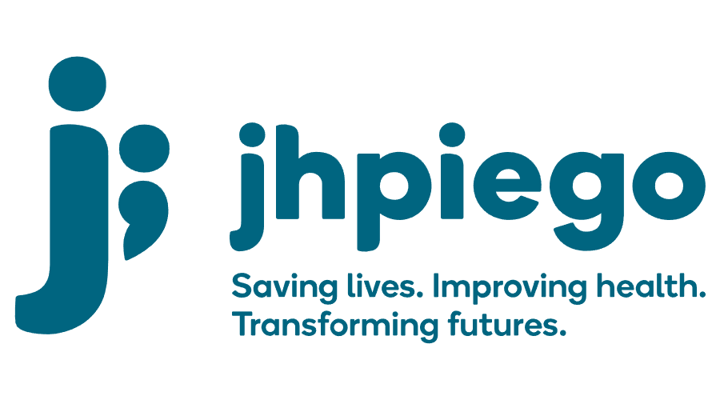

Jhpiego is an international, non-profit health organization affiliated with The Johns Hopkins University. For 40 years and in over 155 countries, Jhpiego has worked to prevent the needless deaths of women and their families.

Jhpiego Corporation has been providing technical support to the Ministries of Health in partner countries across the globe for the past 40 years in a variety of technical areas including cervical cancer treatment and prevention, community health, HIV and AIDS, maternal and newborn health, health workforce capacity development (both pre-service and in-service), family planning, malaria, and IPC/WASH.

The Global Reach II project is a five-year global HRSA-funded project, which started in October, 2021. It employs an iterative approach based on a country’s needs, informed by clients and beneficiaries, targeting high-priority populations and low-coverage and poor-performing areas to achieve HIV epidemic control. In Sierra Leone, Global Reach II works with government and builds local capacity to identify and implement proven solutions where they exist and develop innovative solutions to overcome persistent barriers that affect HIV services. Global Reach II will develop the capacity of the interdisciplinary health workforce to provide quality, client-centered care, ensuring that individuals will be informed and empowered to access services, receive high-quality care, adhere to treatment and remain in care, ultimately contributing to achievement of HIV epidemic control in Sierra Leone.

The following vacant position is available for immediate filling:

Senior Finance and Operations Manager

Position Reports to: Country Program Manager
Job Location: Freetown

Job Summary:
The Finance and Operations Manager (FOM) reports to the Country Program Manager and will be responsible for providing the financial management for Jhpiego projects as assigned and managed. The FOM will oversee all local financial and contractual aspects of Jhpiego projects in Sierra Leone and work closely with project staff to ensure accurate financial and contractual reporting of the project. The FOM will ensure that the financial reports are compatible with standard accounting practices and follow Jhpiego and USAID rules and regulations. The FOM will be responsible for ensuring cost consciousness, efficient spending and for implementing and maintaining an on-site financial accounting and book-keeping system required to assure the integrity and effective performance of project financial operations.

Duties and Responsibilities
Key Financial and Managerial responsibilities:
- Financial planning, budgeting and reporting for Jhpiego active projects in Sierra Leone.
- Provide guidance to the program teams regarding the financial requirements of the projects and office operations.
- Maintains and administers project financial accounting system.
- Implements and oversees a detailed financial reporting and reimbursement process in accordance with Jhpiego's established financial system.
- Review and approve the monthly financial report by using adapted finance software (QuickBooks) and ensures accuracy and timely submission to HQ.
- Supervise Senior Finance Officer to work with local Accounting Firm to track, record and initiate monthly transaction and close the month until QBE is established in country.
- Uses various software applications such as spreadsheets, relational databases, statistical packages, and graphic packages to assemble, analyze, and format data and/or reports
- Ensures financial management systems provides accurate, current, and complete disclosure of financial transactions
- Closely monitors cash flow and assures budgets are followed so spending is on track
- Implements and guide staff on policies and procedures and lead trainings, as needed
- Reviews disbursements and payroll for authenticity and accuracy
- Oversees the financial reporting process to donors

Budget Management
- Prepare accurate budgets, track expenses, ensure that required financial controls and cost-performance monitoring mechanisms are in place and adhered to: prevents over or under-expenditure of budgets, ensures proper safeguards of funds and ensures compliance with established USG and Jhpiego’s global financial, accounting and administrative procedures.
- Leads the development, monitoring, and review of project budgets
- Reviews monthly financial analysis and budget vs expense reports to determine reasonableness of variances and take appropriate actions, as required
- Ensures reasonableness of financial projections
- Makes in-country budget adjustments and other cost improvement measures, as required.
- Cash and Bank Management
- Ensure sufficient funds are available at all times to meet project needs
- Reviews monthly bank reconciliations to ensure balance sheet reconciles to organizational financial records
- Serves as Jhpiego’s liaison with banking officials

Auditing
- Ensure financial records are properly maintained and readily available during audits
- Ensure that in-country legal and statutory requirements (i.e. registration, VAT/Tax reporting, filing tax returns, business licenses etc.) are fully complied
- Lead to facilitate the work of external audits
- Lead to draft responses to audit findings and follow-up on the implementation of audit recommendations

Accounting
- Reviews, reconciles and monitors all project accounts, including major program operating accounts and petty cash operations involving cash advances.
- Determines updated monthly project accruals and projections to support forecasting accuracy and program completion, as required.
- Ensures sound accounting records
- Regularly reviews accounting transactions to ensure costs are allowable and reasonable
- Regularly reviews QBE: review of balance sheet, aging analysis, detailed GL, expenditure by ION, advance balance
- Review monthly QBE replenishment request
- Ensure proper project and financial reporting, spending and compliance with project terms and conditions.
- Ensure that USAID and other donors’ resources are appropriately directed to program priorities and are in line with program work plans.
- Serve as a resource person for non-finance staff on USAID, JHU and Jhpiego rules and policy.
- Provides financial oversight to finance officers
- Ensures compliance by all assigned staff to the JHU and Jhpiego timekeeping requirements, as well as, the staff’s timely approval of timesheets.
- Preforms other projects related activities as assigned by the supervisor or by Jhpiego management

Required Qualification, Knowledge, Skills and Abilities:
- Degree in Accounting, Finance, Business Administration or its recognized equivalent
- MBA in Accounting or professional qualification (CPA, ACCA or recognized equivalent) is required.
- Minimum of 5-8 years relevant experience in finance or accounting.
- Proven experience in Administration
- Knowledge of institutional donors (PEPFAR, USAID/CDC, DFID etc.) regulations, procedures and requirements a plus.

Qualified persons are required to send their Curriculum Vitae (CV) and application letter to: GH-Recruitments@jhpiego.org

Deadline for the submission of applications: November 12, 2021. Please note that given the likely high volume of applications, only shortlisted candidates will be contacted.

