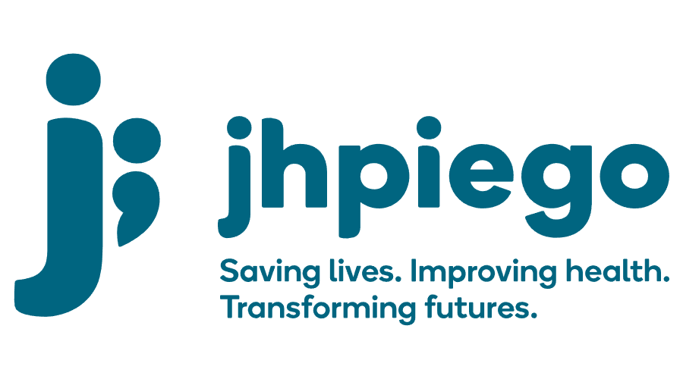

Jhpiego is an international, non-profit health organization affiliated with The Johns Hopkins University. For 40 years and in over 155 countries, Jhpiego has worked to prevent the needless deaths of women and their families.

Jhpiego Corporation has been providing technical support to the Ministries of Health in partner countries across the globe for the past 40 years in a variety of technical areas including cervical cancer treatment and prevention, community health, HIV and AIDS, maternal and newborn health, health workforce capacity development (both pre-service and in-service), family planning, malaria, and IPC/WASH.

The Global Reach II project is a five-year global HRSA-funded project, which started in October, 2021. It employs an iterative approach based on a country’s needs, informed by clients and beneficiaries, targeting high-priority populations and low-coverage and poor-performing areas to achieve HIV epidemic control. In Sierra Leone, Global Reach II works with government and builds local capacity to identify and implement proven solutions where they exist and develop innovative solutions to overcome persistent barriers that affect HIV services. Global Reach II will develop the capacity of the interdisciplinary health workforce to provide quality, client-centered care, ensuring that individuals will be informed and empowered to access services, receive high-quality care, adhere to treatment and remain in care, ultimately contributing to achievement of HIV epidemic control in Sierra Leone.

The following vacant position is available for immediate filling:

Global Reach II Project Lead (1 position)

Job Location: Freetown, Sierra Leone

Reports To: Programmatically: Global Reach II Project Director
Administratively: Country Program Manager, Sierra Leone
Supervises: Technical Advisors, Program Officer

Position Overview: The Global Reach II Project Lead will provide strategic leadership, management and technical oversight of the HRSA and PEPFAR funded, Global Reach II Sierra Leone scope of work which is focused on comprehensive HIV programming across the continuum of care with a focus on key populations. S/he will maintain excellent relationships and collaborate closely with the Government of Sierra Leone, and the National AIDs Control Program (NACP). S/he will utilize mentoring and coaching to support and coach the project team as well as colleagues from NACP and DHMTs. In addition, the position will represent Jhpiego in all technical and managerial aspects of the Global Reach II project within Sierra Leone.

The Global Reach II Project Lead will be responsible and accountable for ensuring that the project is implemented with quality (meeting PEPFAR standards and in line with Sierra Leone NACP HIV national guidelines), within the scope, timeline and budget outlined in the workplan. S/he will provide overall leadership and management support to the GRII project team in Sierra Leone, including the design and oversight the implementation of culturally-appropriate, and KP friendly HIV programming across the 95-95-95 treatment cascade at the national and district level to support national and district led efforts towards epidemic control.

The position will provide direct support to the National AIDS Control Program and work with the project team to support DHMTs, CSOs, Drop-in-Centers (DIC), and project supported health facilities alongside other partners and stakeholders to improve access and quality of HIV programming in Sierra Leone. S/he will work with the Project Team to ensure that comprehensive HIV programming across the continuum of care is achieved with a focus on building and sustaining quality HIV programming across the district and national government structures, and local CSOs. The Technical Advisor will lead coordination and strategy alongside National AIDS Control Program (NACP) and National HIV/AIDS Secretariat (NAS), cooperating partners and other stakeholders in the areas of HIV/AIDS prevention, care and treatment to support the implementation of national level health policies and strategies in relation to HIV-programming with a focus on key populations. S/he will promote and ensure proper integration of HIV programming activities with other activities such as TB screening and prevention.

Duties and Responsibilities:
- Provide strategic leadership, management and technical oversight of the HRSA-funded, PEPFAR, Global Reach II Sierra Leone scope of work.
- Provide technical oversight for the development and implementation, monitoring and evaluation of global and national guidelines pertaining to HIV programming in Sierra Leone.
- Provide programmatic leadership for, and oversee, in coordination with the Global Reach Project Director, the strategic planning of activities in support of the program goals and objectives, including the determination of program priorities and appropriate technical initiatives.
- Support the development, implementation and tracking of capacity building plans for local NGOs/CSOs.
- Collaborate with the Country Program Manager and Global Reach II Project Director alongside relevant STTA to mentor, coach and support a team of highly qualified technical staff and align their efforts in concert with program goals to ensure rapid and sustainable results.
- Oversee the development of district – specific quarterly and monthly implementation plans by the district technical teams (in alignment with the overall project annual workplan).
- Work collaboratively with the technical and program staff to ensure quality and efficient program planning, implementation, and monitoring.
- Lead the development of strategies and activities fostering government sustainability and ownership of HIV programming at national and district levels.

Oversee the forecasting, procurement, and distribution of project commodities and supplies (HIV Rapid Test Kits, lab supplies, and other supplies) for project implementation

Work collaboratively with SI team to ensure that appropriate data is collected and that data are being used and shared for decision-making

Coordinate the work of all team members with their designated counterparts within HRSA, the MOH, Clinical and Public Health Lab, UNAIDS, NAS, as well as partners and other key stakeholders in Sierra Leone such as NGOs implementing key population programs, to ensure effective technical assistance, strong partnership and the smooth implementation of activities

Advise national counterparts on technical issues and participate in relevant advisory and/or working groups with counterparts and partner institutions

Write and/or review technical components of materials and publications related to the program and its development

Ensure resources for program implementation are available

Represent Jhpiego, Global Reach II in public and professional circles through meetings, conferences, and presentations

Take overall leadership in the management of project staffing (volunteers, temporary and permanent hires) in alignment with project’s human resource needs

Work closely with Global Reach II and Jhpiego home office program team and Technical Advisors to ensure effective, timely and coordinated project implementation

Ensure compliance with USG and Jhpiego operational policies and regulations

Coordinate project activities with the MOH-NACP, Global Fund, UNAIDs, NAS and other stakeholders

Provide/support technical assistance/expert inputs to the government to strengthen the quality and access of HIV services

Support NACP in alignment of HIV programming with global best practices and PEPFAR minimum requirements

Support competency-building and training activities

Leverage Jhpiego’s and HRSA’s international networks to connect country leadership to relevant points of contact in the international community working on border health and point of entry issues, to advance the emergency contingency plans for border crossing points,

Undertake other leadership, coordination and management activities relevant to the project

Other duties as required by the project

Qualifications:

Health degree (doctor, clinical officer or nurse) required, with additional post-graduate training in public health desirable

Master’s degree in epidemiology, statistics, public policy or related health sciences field, Field Epidemiology Training Program graduate preferred

At least 7 years demonstrated experience working in one or more areas of HIV prevention including: HIV counseling and testing including self-testing, PrEP, HIV care and treatment (required), linkage case management, PMTCT, or other applicable area.

Experience and skills

At least seven years’ related experience, at national level, in quantitative epidemiology and the implementation of public health surveillance, outbreak investigation and response

At least three years’ experience in leading and managing donor funded programs and teams

Technical expertise in disease surveillance of infectious diseases

Knowledge and experience of IDSR guidelines and operating mechanisms

Proficiency in analysis, interpretation and visualization of data; experience in integrating qualitative and geospatial analysis a plus

Demonstrated skills in training / orientating teams

Proven ability to multitask across various planning and implementation processes within a highly demanding environment.

Excellent writing, verbal and interpersonal communication skills in English.

Proficiency in Microsoft Office, Epi-info, DHIS2 and other reporting platforms

Ability and willingness to travel in the country

Qualified persons are required to send their Curriculum Vitae (CV) and application letter to: GH-Recruitments@jhpiego.org

Deadline for the submission of applications: November 12, 2021. Please note that given the likely high volume of applications, only shortlisted candidates will be contacted.

