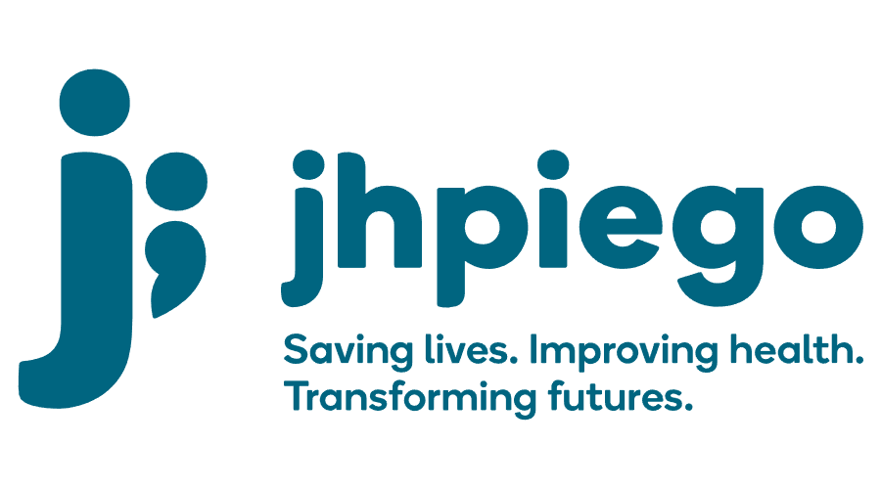

Jhpiego is an international, non-profit health organization affiliated with The Johns Hopkins University. For 40 years and in over 155 countries, Jhpiego has worked to prevent the needless deaths of women and their families.

Jhpiego Corporation has been providing technical support to the Ministries of Health in partner countries across the globe for the past 40 years in a variety of technical areas including cervical cancer treatment and prevention, community health, HIV and AIDS, maternal and newborn health, health workforce capacity development (both pre-service and in-service), family planning, malaria, and IPC/WASH.

The Global Reach II project is a five-year global HRSA-funded project, which started in October, 2021. It employs an iterative approach based on a country’s needs, informed by clients and beneficiaries, targeting high-priority populations and low-coverage and poor-performing areas to achieve HIV epidemic control. In Sierra Leone, Global Reach II works with government and builds local capacity to identify and implement proven solutions where they exist and develop innovative solutions to overcome persistent barriers that affect HIV services. Global Reach II will develop the capacity of the interdisciplinary health workforce to provide quality, client-centered care, ensuring that individuals will be informed and empowered to access services, receive high-quality care, adhere to treatment and remain in care, ultimately contributing to achievement of HIV epidemic control in Sierra Leone.

The following vacant position is available for immediate filling:

Technical Officer (4 positions)

Job Locations: Freeport (2), Port Loko (2)

Reports to: Senior Technical Officer
Supervises: Health Volunteers

Position Overview:
The Technical Officer will provide technical support in the implementation and expansion of integrated quality HIV services to both the general and key populations (KPs) at program supported health facilities and drop-in centers. S/he will provide technical assistance and support in the implementation of comprehensive facility-based HIV services including PrEP, HTS (including index testing), HIVST, Care and Treatment and linkage to care. They will also provide support to specific mobile and outreach services and services targeting populations (e.g. men, KPs). S/he will directly support health facility staff and volunteers at site level and contribute to the improvement of access and quality of HIV services including the optimization of HTS, referrals/linkages with HIV/AIDS care and treatment, other services and the implementation of QI approaches. S/he will provide mentorship and support to health facility staff and volunteers at health facilities and DICs in the provision of HIV counseling and testing services including adherence counseling, TB screening and prevention, HIVST, PrEP and other health screening and referrals.

The position will support the Senior Technical Officers and Advisor to identify capacity and skills gaps and implement targeted on the job trainings for the provision of comprehensive and high-quality HIV, and KP-friendly services. S/he will, in collaboration with the health facility and drop-in center staff, provide oversight and mentorship to the volunteers at the health facility that are supporting demand creation for services, linkages to care, partner tracing, loss to follow up and peer support. S/he will also collaborate with other organizations and the communities to support HIV services across the continuum of care.

Duties and Responsibilities:
- Supports health facility and drop-in center staff in the coordination, supervision and provision of HIV testing and Services (HTS), HIVST, PrEP, linkages to care and treatment support, TB, STI and other health services at health facilities
- Mentors and trains health facility staff and volunteers on comprehensive and quality HIV services including, PrEP, HIVST (including index testing), clinical management of people living with HIV, TB screening, and counseling provided at health facilities and outreach sites
- Ensures all clinical procedures at health facilities and outreaches follow national guidelines and protocols developed by the NACP and PEPFAR minimum requirements.
- Provides on-going coaching, mentoring and hands-on supervision to health facility staff and volunteers
- Supports health facility and drop-in center staff to implement patient flow, protocols and supports site level standard operating procedures for comprehensive HIV services
- Ensures linkages of newly diagnosed clients to care, in collaboration with health facility and drop-in center staff and volunteers
- Supports health facility staff to conduct weekly data review meetings and determines pivots or adjustments to implementation, in collaboration with the SI officers and SI assistants
- Provides technical assistance and participate in supportive supervision of clinical staff to ensure quality health care delivery; support the DHMTs to do the same in select sites
- Trains counselors and volunteers in HIV, HIVST, PrEP, community and adherence counseling, patient advocacy, case management and partners tracing
- Provide logistic support and oversight of laboratory sample transport and commodities and supplies for HIV services
- Contributes to monthly, quarterly and annual reports with progress as per donor requirements.
- Participates in various learning activities
- Performs other duties as required by the project

Knowledge, Skills and Experiences:
- Robust clinical experience in HIV/AIDS testing and counseling, care and treatment
- Experience in KP-focused clinical services is a plus
- Excellent written, presentation, communication and organizational skills in English
- Demonstrated experience in clinical training and mentoring
- The ability to liaise with DHMTs and representatives of stakeholders
- Demonstrated in-depth understanding of Sierre Leone healthcare system, particularly the public health system, experience living and working in Sierra Leone preferred
- Ability to travel nationally up to 30%

Qualifications
- Clinical officer or holder of nursing degree
- Holder of advanced degree in Public Health, MBA is a bonus
- Experience working in HIV prevention and treatment a bonus

Qualified persons are required to send their Curriculum Vitae (CV) and application letter to: GH-Recruitments@jhpiego.org

Deadline for the submission of applications: November 12, 2021. Please note that given the likely high volume of applications, only shortlisted candidates will be contacted.

