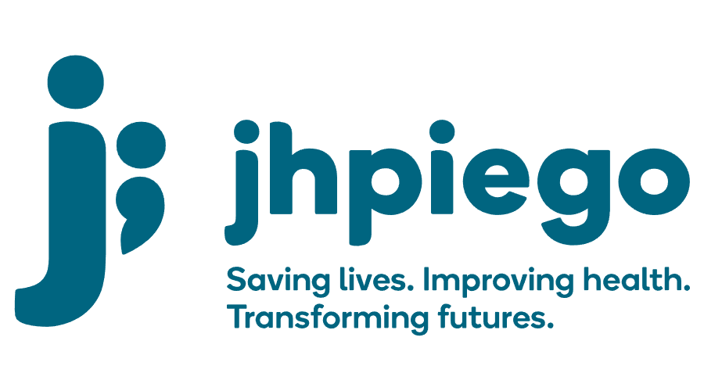

Jhpiego is an international, non-profit health organization affiliated with The Johns Hopkins University. For 40 years and in over 155 countries, Jhpiego has worked to prevent the needless deaths of women and their families.

Jhpiego Corporation has been providing technical support to the Ministries of Health in partner countries across the globe for the past 40 years in a variety of technical areas including cervical cancer treatment and prevention, community health, HIV and AIDS, maternal and newborn health, health workforce capacity development (both pre-service and in-service), family planning, malaria, and IPC/WASH.

The Global Reach II project is a five-year global HRSA-funded project, which started in October, 2021. It employs an iterative approach based on a country’s needs, informed by clients and beneficiaries, targeting high-priority populations and low-coverage and poor-performing areas to achieve HIV epidemic control. In Sierra Leone, Global Reach II works with government and builds local capacity to identify and implement proven solutions where they exist and develop innovative solutions to overcome persistent barriers that affect HIV services. Global Reach II will develop the capacity of the interdisciplinary health workforce to provide quality, client-centered care, ensuring that individuals will be informed and empowered to access services, receive high-quality care, adhere to treatment and remain in care, ultimately contributing to achievement of HIV epidemic control in Sierra Leone.

The following vacant position is available for immediate filling:

Program Officer

Position Reports to: Country Program Manager
Job Location: Freetown

Job Summary:
Jhpiego is seeking a Program Officer to provide high quality administration and management for newly awarded COVID-19 projects. In Sierra Leone, Jhpiego will support the Government of Sierra Leone to control and mitigate the spread of the novel coronavirus. A significant area of focus for our work is accelerating and strengthening the technical and operational capacity of local healthcare workers to reduce the spread of infection, provide quality case management and allow for the safe maintenance routine essential services.

The Program Officer will assist in the implementation, project management and administrative support for several COVID-19 response projects being implemented at the national, regional, district and primary health care level. This includes assisting with development of work plans, liaising with Ministry staff, other partners and donors regarding implementation, monitoring and evaluation of project milestones and targets.

Duties and Responsibilities:
- Lead program coordination and monitor implementation
- Implementation and monitoring of work plan and budgets
- Coordinate technical assistance for program implementation
- Assist the technical staff in the design implementation, monitoring and assessment of activities.
- Write reports, project monitoring tracking matrices and relevant reports as required.
- Work closely with technical and program staff to ensure quality implementation of programs and monitor state level spending
- Assist in the development of new program approaches that are linked to related services
- Work with Jhpiego COVID-19 response consultants to implement trainings, maintain services and supportive supervision
- Other duties as necessary or as assigned

Required Qualification, Knowledge, Skills and Abilities
- Bachelor’s degree (advanced degree preferred) or equivalent experience in public health, sociology, or related health, management, or social science discipline.
- Demonstrated experience working with USAID programs and strong familiarity with USG reporting requirements.
- 5+ years’ experience in management, operational and technical expertise with a preference in public health program implementation
- Experience in public health as well as infection prevention and control programs
- Familiarity with Sierra Leone health systems and reporting structure and demonstrated ability to collaborate with government level officials to strengthen program implementation
- Demonstrated ability in working and collaborating with a wide range of local and international partner organizations
- Excellent skills in facilitation, team building and coordination
- Excellent writing and communications skills, including demonstrated technical writing skills for publication
- Ability to work effectively with diverse international teams and willingness to learn and empower others
- Ability to work in a complex environment with multiple tasks, short deadlines and intense pressure to perform
- Ability and willingness to travel frequently to implementation regions and health facilities
- Familiarity and experience working with Zoom and other virtual platforms

Qualified persons are required to send their Curriculum Vitae (CV) and application letter to: GH-Recruitments@jhpiego.org

Deadline for the submission of applications: November 12, 2021. Please note that given the likely high volume of applications, only shortlisted candidates will be contacted.

