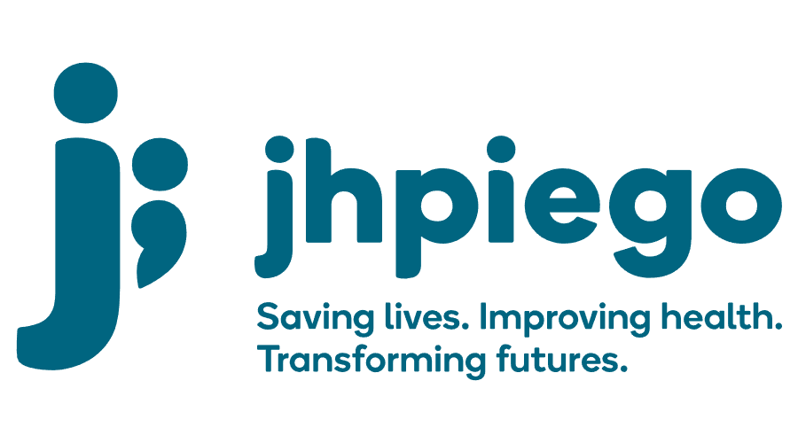

Jhpiego is an international, non-profit health organization affiliated with The Johns Hopkins University. For 40 years and in over 155 countries, Jhpiego has worked to prevent the needless deaths of women and their families.

Jhpiego Corporation has been providing technical support to the Ministries of Health in partner countries across the globe for the past 40 years in a variety of technical areas including cervical cancer treatment and prevention, community health, HIV and AIDS, maternal and newborn health, health workforce capacity development (both pre-service and in-service), family planning, malaria, and IPC/WASH.

The Global Reach II project is a five-year global HRSA-funded project, which started in October, 2021. It employs an iterative approach based on a country’s needs, informed by clients and beneficiaries, targeting high-priority populations and low-coverage and poor-performing areas to achieve HIV epidemic control. In Sierra Leone, Global Reach II works with government and builds local capacity to identify and implement proven solutions where they exist and develop innovative solutions to overcome persistent barriers that affect HIV services. Global Reach II will develop the capacity of the interdisciplinary health workforce to provide quality, client-centered care, ensuring that individuals will be informed and empowered to access services, receive high-quality care, adhere to treatment and remain in care, ultimately contributing to achievement of HIV epidemic control in Sierra Leone.

The following vacant position is available for immediate filling:

Senior Technical Officer (4 positions)

Job Locations: Freeport (2), Port Loko (1), KP focused position (1)

Reports to: Relevant Technical Advisor
Supervises: Technical Officers

Position Overview:
The Senior (Sr.) Technical Officer in collaboration with the Technical Advisors (Tas), will provide strategic oversight and technical support in the implementation and expansion of integrated quality HIV services to both the general and key populations (KPs) at program supported health facilities and drop-in centers (DICs). One (1) Sr Technical Officer position will be KP focused will closely with the KP Technical Advisor on KP friendly programming.

The Sr Technical Officer positions will provide strategic support, oversight and technical assistance to the implementation of comprehensive facility-based HIV services including PrEP, HTS (including index testing and HIVST), Care and Treatment and linkage to care. They will also provide strategic support to DICs and health facilities conduct specific mobile and outreach services and services targeting populations (e.g., KPs, men). S/he will work closely with the technical officers to directly support health facility staff and volunteers at site and DIC level and contribute to the improvement of access and quality of HIV services including the optimization of HTS, referrals/linkages with HIV/AIDS care and treatment, other services (including lab) and the implementation of QI approaches. S/he will provide mentorship and support to health facility staff and volunteers at health facilities and DICs in the provision of HIV prevention (including PrEP) optimized HTS (including HIVST and index testing), adherence counseling, TB screening and prevention, laboratory services, other health screening and referrals and QI/QA activities.

The position will work with Technical Officers and Advisors to identify capacity and skills gaps and implement targeted on-the-job trainings and mentorship for the provision of comprehensive and high-quality HIV, and KP-friendly services. S/he will, in collaboration with the health facility and DIC staff, provide oversight and mentorship to the project Technical Officers alongside the volunteers at the health facility and DIC that are supporting demand creation for services, linkages to care, partner tracing, loss to follow up and peer support. S/he will also collaborate with other organizations and the communities to support HIV services across the continuum of care.

Duties and Responsibilities:
- Supports Technical Officers and health facility and drop-in center staff in the coordination, supervision and provision of optimized HTS (HIVST and index testing), HIV prevention (including PrEP), linkages to/and care and treatment support, TB and other health services at health facilities.
- Mentors and trains Technical Officers, health facility staff and volunteers on comprehensive and quality HIV services across the continuum of care and the clinical management of people living with HIV, integrated TB screening and prevention, and counseling provided at health facilities and outreach sites
- Ensures all clinical procedures at health facilities and outreaches follow national guidelines and protocols developed by the NACP and meet PEPFAR minimum requirements.
- Provides on-going coaching, mentoring and hands-on supervision to technical officers, health facility staff and volunteers
- Develops patient flow, protocols and supports site level standard operating procedures for comprehensive HIV services
- Ensures linkages of newly diagnosed clients to care, in collaboration with health facility staff and volunteers,
- Supports health facility and drop-in center staff to conduct weekly data review meetings and determines pivots or adjustments to implementation, in collaboration with the SI officers and SI assistants,
- Provide logistic support and oversight of laboratory sample transport and commodities and supplies for HIV services
- Provides technical assistance and participate in supportive supervision of clinical staff to ensure quality health care delivery; support the DHMTs to do the same in select sites
- Trains counselors and volunteers in HIV, HIVST, PrEP, community and adherence counseling, patient advocacy, case management and partners tracing
- Contributes to monthly, quarterly and annual reports with progress as per donor requirements.
- Participates in various learning activities
- Performs other tasks as required by the project

Knowledge, Skills and Experiences:
- Robust clinical experience in HIV/AIDS testing and counseling, care and treatment
- Experience in KP-focused clinical services is a plus
- Excellent written, presentation, communication and organizational skills in English
- Demonstrated experience in clinical training and mentoring
- Ability to liaise with DHMTs and representatives of stakeholders
- Demonstrated in-depth understanding of Sierre Leone healthcare system, particularly the public health system, experience living and working in Sierra Leone preferred
- Ability to travel nationally up to 50% of the time

Qualifications
- MD, Pharmacist, Clinical Officer or holder of nursing degree
- Holder of advanced degree in Public Health or MBA is a bonus
- At least 1 year demonstrated experience working in HIV prevention and treatment

Qualified persons are required to send their Curriculum Vitae (CV) and application letter to: GH-Recruitments@jhpiego.org

Deadline for the submission of applications: November 12, 2021. Please note that given the likely high volume of applications, only shortlisted candidates will be contacted.

