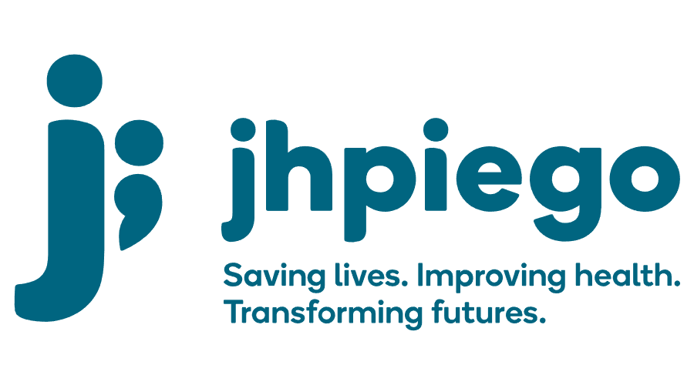

Jhpiego is an international, non-profit health organization affiliated with The Johns Hopkins University. For 40 years and in over 155 countries, Jhpiego has worked to prevent the needless deaths of women and their families.

Jhpiego Corporation has been providing technical support to the Ministries of Health in partner countries across the globe for the past 40 years in a variety of technical areas including cervical cancer treatment and prevention, community health, HIV and AIDS, maternal and newborn health, health workforce capacity development (both pre-service and in-service), family planning, malaria, and IPC/WASH.

The Global Reach II project is a five-year global HRSA-funded project, which started in October, 2021. It employs an iterative approach based on a country’s needs, informed by clients and beneficiaries, targeting high-priority populations and low-coverage and poor-performing areas to achieve HIV epidemic control. In Sierra Leone, Global Reach II works with government and builds local capacity to identify and implement proven solutions where they exist and develop innovative solutions to overcome persistent barriers that affect HIV services. Global Reach II will develop the capacity of the interdisciplinary health workforce to provide quality, client-centered care, ensuring that individuals will be informed and empowered to access services, receive high-quality care, adhere to treatment and remain in care, ultimately contributing to achievement of HIV epidemic control in Sierra Leone.

The following vacant position is available for immediate filling:

Technical Advisor – Training and Capacity Lead (1 position)

Job Location: Freetown, Sierra Leone

Reports to: Global Reach Country Lead
Supervises: Senior Technical Officers, Technical Officers

Position Overview:
The Technical Advisor- Training and Capacity Lead will serve as the lead technical advisor for all Global Reach II Project’s trainings and capacity building activities across the project and will also offer technical support to various HIV programming areas. The position will provide technical leadership and project oversight in the areas of building capacity of national and district leaders, developing project staff training and mentorship approaches, designing health care worker/community health volunteer (HCW/CHW) training and capacity building approaches in HIV service provision include HTS (including index testing), PrEP, Care and Treatment, Linkage to Care, Counseling, NIMART, TB, Quality Improvement/Quality Assurance (QI/QA), KP friendly services, digital health systems, networks of care, community led monitoring, laboratory, and data quality and use as it relates to comprehensive HIV programming. S/he will work with the Global Reach II Country Lead and the Project Team to ensure that KP friendly HIV programming is implemented to meet the PEPFAR requirements with a focus on building and sustaining quality HIV programming across the district and national government structures, and local CSOs. The Technical Advisor- Training and Capacity Lead will also provide technical assistance at the National level ensuring ongoing capacity and expertise is built within the existing MOH/NACP structures in the areas of HIV service provision, QI/QA, laboratory, TB, community led monitoring, leadership and management and data quality and use for sustainability.

Duties and Responsibilities:
- Provides technical oversight, strategic direction and definition of appropriate project activities with a focus on capacity building health care workers, community health workers and local and national level government authorities.
- Supports implementation of a system to ensure capacity and technical quality of trained health care workers, managers and supervisors to ensure high quality provision of comprehensive HIV services across the continuum of care
- Develops and/or update evidence-based training materials, standards, job aids, and curricula, supervisory systems needed for implementation of the Project to meet the needs of PEPFAR, HRSA and Sierra Leone
- Provides mentoring and capacity building at the individual, facility, district, regional and national levels in specific areas of expertise including but not limited to:
  - Strengthening relevant departments of the MOH to plan, lead and oversee training of MOH staff to become effective leaders and managers of training and mentorship processes.
  - Advocating with MOH to design, refine and facilitate HIV trainings using innovative, cost efficient and effective training/learning approaches.
  - Working closely with stakeholders to strengthen national HIV training packages/systems including supplementary trainings such as leadership and management, quality assurance/quality improvement, data quality and use,
  - Supporting the overall change management process related to improving health training systems
  - Collaborating closely with Project Technical Advisors, and Government QI/QA, SI and Laboratory leads on training needs and approaches to support both project and NACP objectives and outcomes.
  - Key population friendly services
- Provides technical assistance for targeted reviews of in-service and/or pre-service education needs impacting HIV services, and related supportive supervision activities and implementation
- Coordinates advocacy, and policy and training support, across project regions as required
- Leads the formulation of innovative approaches for sustained capacity and scale up of targeted HCW/CHW/volunteer capacity building HIV service provision, QI/QA in HIV prevention, care, and treatment as it relates to HIV across the continuum of care, laboratory and data quality and use services
- Participates actively in relevant technical advisory/working groups and professional forums representing the project and/or Global Reach II
- Works with health care providers, local authorities, community members and project team members to identify clinical, community-based to national service delivery issues that impede access to care and uptake of services and develop context-based solutions
- Identifies and implements appropriate facility- and community-based strategies to address HCW/CHW capacity building in HIV service provision, laboratory services and management, QI/QA in HIV care across the continuum and data quality and use and other targeted areas identified from service delivery gaps
- Identifies training needs for clinical and community healthcare providers and assist in the design and implementation of measures to address those needs
- Works closely with the Global Reach II Country Lead, Technical Advisors and the National AIDS Control Program on setting project priorities and directions, and responding to requests for support from local counterparts
- Works with SI staff and National AIDS Control Program to design, implement a plan to track data/results related to targeted HCW/CHW capacity building in QI/QA, data use, and reporting of HIV services = to inform adjustments in project implementation
- Collaborates with all local stakeholders and implementing partners, especially the National AIDS Control Program, and other US, Global Fund and implementing partners and local CSOs, to ensure that all activities conform to the requirements and regulations
- Documents successes, lessons learned and challenges in implementation as well as reports of project activities and results to the project and donor, including routine quarterly and annual reports and other reporting requirements as requested
- Documents and maintains an inventory of successful tools and approaches for targeted HCW/CHW capacity building in HIV service provision, QI/QA, data quality and use and HIV services across the continuum to inform adjustments in project implementation
- Authors/co-authors abstracts, presentations, and articles for journals and conferences
- Supervises technical staff
- Maintains excellent relationships with HRSA, National AIDS Control Program, and in-country stakeholders and develop rapid responses
- Provides technical leadership to the development the project strategic plan, work plan, and project monitoring, in close collaboration with HRSA, NACP and Sierra Leone government at all levels and IPs to ensure timely implementation and compliance to the requirements and regulations of the award
- Performs other duties as required by the project

Required Qualifications:
- Health Degree (doctor or nursing) required, and Master of Public Health preferred
- At least 2-3 years’ experience implementing and/or providing technical assistance in HCW/CHW capacity building, specifically in QI/QA and HIV prevention, treatment, and care
- Demonstrated experience providing capacity building assistance at individual and organizational levels
- Skilled in at least two or more of the following technical areas: strengthening service delivery projects; training; pre-service or in-service education; performance and quality improvement; monitoring and evaluation
- Demonstrated experience with a mix of practical technical skills in QI/QA initiatives and standardization for HIV prevention, treatment, and care at the regional, national, clinical and community-level
- Demonstrated in-depth understanding of Sierra Leone healthcare system, particularly the public health system, experience living and working in Sierra Leone preferred
- Familiarity with PEPFAR administrative, management and reporting procedures and systems
- Excellent diplomacy skills and a proven ability to establish and maintain interpersonal and professional relationships with facility-based teams, stakeholders and NGOs, CSOs
- Expertise in research to practice—identifying and adapting best practices to specific project contexts
- Excellent verbal, written interpersonal and presentation skills in English
- Proficiency in Microsoft Office
- Ability to travel nationally to project sites up to 50% of the time
Qualified persons are required to send their Curriculum Vitae (CV) and application letter to: GH-Recruitments@jhpiego.org

Deadline for the submission of applications: November 12, 2021. Please note that given the likely high volume of applications, only shortlisted candidates will be contacted.

