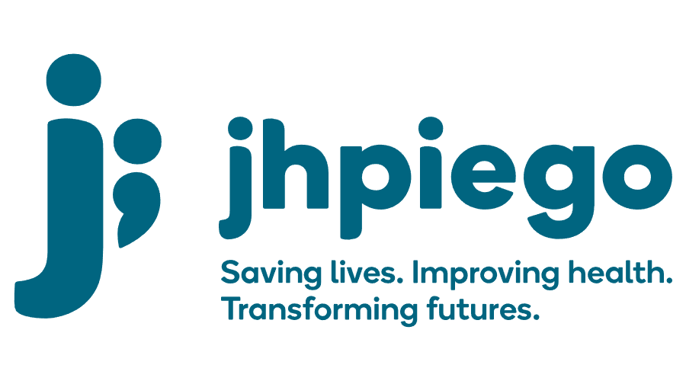

Jhpiego is an international, non-profit health organization affiliated with The Johns Hopkins University. For 40 years and in over 155 countries, Jhpiego Corporation has been providing technical support to the Ministries of Health in partner countries across the globe for the past 40 years in a variety of technical areas including cervical cancer treatment and prevention, community health, HIV and AIDS, maternal and newborn health, health workforce capacity development (both Pre-service and in-service), family planning, malaria, and IPC/WASH.

The following vacant position is available for immediate filling:

Data Manager (1 position)

Job Location: Freetown, Sierra Leone

Reports to: Strategic Information Advisor

Position Overview:
The Data Manager will be responsible for the management of all project data. S/he will also lead and maintain the activity Indicator Tracking Table (ITT) and ensure data quality for all data entered, summarized, and reported by Project. S/he will provide support to all data collection, cleaning and analysis and play a key role in data review meetings; reporting in PEPFAR Data for Accountability Transparency and Impact (DATIM), GR-II database, and DHIS 2, writing donor reports and participating in information dissemination forums. S/he will:
- Submit 100% quality data in DATIM and DHIS 2 every month
- Develop, refine and use data analytics and visualizations tools
- Report for High-frequency reporting and Early Warning indicators
- Supervise data entry, cleaning, and validation for Jhpiego DHIS2 interphase, DATIM, and all other project systems before reporting
- Support the district and national interactive dashboard
- Provide timely trend analysis for project performance tracking for project management on a weekly basis
- Manage all project-related databases and systems and build the capacity of the team to use these systems.

Duties and Responsibilities:
- Oversee the timely collection, verification& validation, entry, processing, review, and collation of project data for all reportable indicators – from DHIS2, DATIM, and other sources (health facilities and the community).
- Work closely with digital health advisor, GRII technical program experts, and MoH to develop, refine and use data analytics and visualization tools.
- Perform data cleaning and verify the authenticity and accuracy of the data before reporting to the project, Jhpiego, Partners, and to the donor.
- understanding database design concepts and being able to participate in short and long-term planning about database projects.
- Review, analyze, select and implement current database technologies suitability for existing infrastructure.
- Maintain database disaster recovery processes and provide regular updates to project lead and management on project databases status and the efficacy of the disaster recovery mechanisms.
- Store data across multiple premises including clouds using a sustainable approach
- Develop a data query log on a monthly/quarterly basis to address and document data-related queries with the project technical team
- Develop and oversee the implementation of guidelines/SOPs for data entry, management, and analysis.
- Work closely with M&E and IT teams to develop and/or review project data management systems including data security, analysis plan, dissemination aids, and templates.
- Contribute to the development of in-depth analysis of HSDSA cluster 3 project data for publications, advocacy, proposal writing, and presentation to various audiences as the need arises.
- In close collaboration with the project technical leads, conduct in-depth and robust data analysis and presentation for project performance analytics to guide management decisions.
- Participate in project-led special initiatives, surveys, and studies and provide technical assistance in data management and report writing.
- Assist in the writing of quarterly and annual project reports, and processing, reviewing, and submission of project data through DATIM, database, and TraiNet systems.
- Assist in data quality assessments to review the quality of data at the project level, DHIS2, and source documents at facility and community levels.
- Participate in data review meetings at various levels, including the project level.
- Perform other M&E, technical and administrative duties as necessary and as may be assigned.

Required Qualifications:
- A bachelor’s degree in statistics, Epidemiology, Biostatistics, health, and statistical science or a related field - an advanced degree will be an added advantage
- Five years of work experience in M&E specifically in data management and analysis of health-related data for PEPFAR-funded projects
- Experience working with MOH systems and personnel an asset
- Demonstrated experience in data analysis, visualization, and presentation of data;
- Experience working in/ with HIV care and treatment facilities
- Deep understanding of the project and national HIV tools and key data elements required for reporting PEPFAR indicators and monitoring technical quality
- Excellent analytical, oral, and report-writing skills
- Computer literacy, particularly in the use of MS Excel, and PowerPoint. MS Access and SPSS or other data analysis software.
Required Abilities/Skills:
- Ability to work in a complex environment with multiple tasks, short deadlines and intense pressure to perform
- Ability and willingness to learn new competencies;
- Dependable, possess utmost Integrity and unparalleled attention to detail
- Excellent communication, presentation and writing skills;
- Experience in public speaking and professional presentations;
- Field oriented and comfortable with a team approach to programming;
- Ability to manage several major activities simultaneously;

Qualified persons are required to send their Curriculum Vitae (CV) and application letter to: SL-Recruitment@jhpiego.org
Deadline for the submission of applications: 28th November, 2022. Please note that given the likely high volume of applications, only shortlisted candidates will be contacted.

