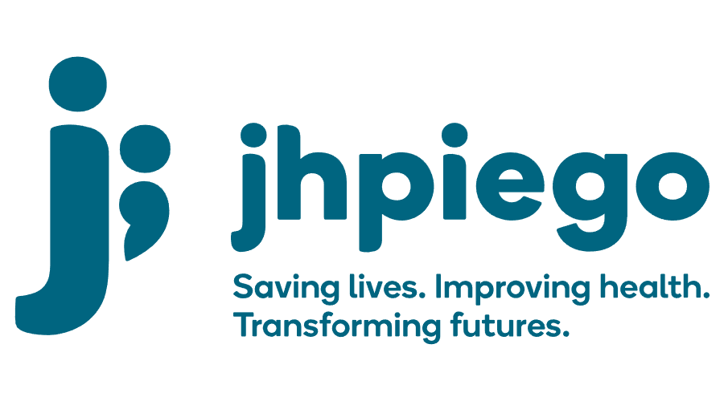

Jhpiego is an international, non-profit health organization affiliated with The Johns Hopkins University. For 40 years and in over 155 countries, Jhpiego has worked to prevent the needless deaths of women and their families.

Jhpiego Corporation has been providing technical support to the Ministries of Health in partner countries across the globe for the past 40 years in a variety of technical areas including cervical cancer treatment and prevention, community health, HIV and AIDS, maternal and newborn health, health workforce capacity development (both pre-service and in-service), family planning, malaria, and IPC/WASH.

The Global Reach II project is a five-year global HRSA-funded project, which started in October, 2021. It employs an iterative approach based on a country’s needs, informed by clients and beneficiaries, targeting high-priority populations and low-coverage and poor-performing areas to achieve HIV epidemic control. In Sierra Leone, Global Reach II works with government and builds local capacity to identify and implement proven solutions where they exist and develop innovative solutions to overcome persistent barriers that affect HIV services. Global Reach II will develop the capacity of the interdisciplinary health workforce to provide quality, client-centered care, ensuring that individuals will be informed and empowered to access services, receive high-quality care, adhere to treatment and remain in care, ultimately contributing to achievement of HIV epidemic control in Sierra Leone.

The following vacant position is available for immediate filling:

Strategic Information Advisor (1 position)
Job Location: Freetown

Reports to: Global Reach Project Lead
(Administratively, with technical oversight by Global MEL Specialist)
Supervises: SI Officers

Position Overview:
Working under the supervision of Global Reach II Project Lead with technical oversight from the Global MEL Specialist, the Strategic Information Advisor works with the in country Technical Advisors, Partner and MOH to ensure that high-quality M&E practices are included in country-based activities and work plans, that indicators and M&E plans conform to Global Reach II project, PEPFAR and government standards and protocols, and that evidence, lessons learned and best practices are appropriately captured, documented, disseminated and integrated to improve implementation. S/he will lead data collection, reporting and analysis of data to identify areas of improvement. S/he will manage all M&E/SI related staff in the project.

Duties and Responsibilities:
- Develop and maintain key relationships with colleagues, Government staff, other IPs, CSOs
- Develop, refine, and track project performance on indicator tracking table (ITT) to capture results (including sub-contractor performance) to ensure that the project achieves its objectives, within the required timelines.
- Develop, refine, and implement SOPs for data collection, management, and use at site-level to ensure that data meets minimum quality standards.
- Lead site-level data verification, Data Quality Assessments (DQAs) and audits; while ensuring that they are routinely carried out during the project lifecycle
- Leads development of SI elements of the work plan and budget.
- Develop individual weekly work plan and tracks their own deliverables
- Lead weekly, monthly, quarterly data review at site, district, and project level, and ensure prompt follow-up of action items. In addition, review data regularly with government of Sierra Leone and ensures harmonization of project data in national systems
- Analyzes and provide key information on progress towards indicator targets, assessing program quality and management effectiveness
- Lead PEPFAR indicator reporting as required by HRSA/PEPFAR, MOH and project learning priorities
- In collaboration with project, technical and finance staff, track program constraints—time, cost and scope—via user-friendly dashboards, to ensure program spending is commensurate with results, in line with PEPFAR guidance. Support the project to provide Ministry of Health technical assistance to strengthen the country’s HMIS for the optimal use of routine HMIS data
- Ensure relevant data is entered into JADE, Jhpiego’s organization-wide performance management system designed to capture, analyze, and disseminate project data
- Foster a culture of continuous learning and improvement in the project; integrate learning into day-to-day activities by developing, implementing and refining a project learning agenda
- Identify SI-related training needs across all staff (project, MOH and stakeholders) and develop training and implement cost-effective, competency-based training
- Oversee the team to manage forecasting, inventory and tracking of SI-related tools and devices
- Oversee the team to ensure functioning and timely user support for SI-related devices and processes to assure real-time reporting
- Adapt/update/develop data quality assessment plan, tools and procedures and report out on data quality and prioritize key actions to improve data quality
- Adapt/update/develop plan for strong data visualizations and ensure the delivery of the same

Required Qualifications, Experience and Skills:
- Masters or PhD in Public Health or related field (sciences, medicine, nursing, demography)
- At least 5 years of experience in a senior SI role with a PEPFAR HIV prevention, Care and Treatment project
- Experience working in/ with HIV care and treatment facilities
- Deep understanding of project and national HIV tools and key data elements required for reporting PEPFAR indicators and monitoring technical quality
- Strong knowledge of PEPFAR indicators, including DATIM reporting
- Understands the ‘big picture’ project goal, proposing a strategic way forward to achieve the goal, laying out the risks and a plan to mitigate them
- Excellent spoken and written English skills, including technical writing skills for publication
- Demonstrated ability to work under pressure and collaborate as a team to achieve results
- Proficient in day-to-day prioritizing, organizing work flow, delegating and setting expectations, and following up on them
- Extensive knowledge of the local health systems
- Experience working with CSOs will be an added advantage.
- Experience with community-based HIV service delivery or key population programming
- Excellent written and oral communication and presentation skills in English and Kiswahili
- Willingness to travel domestically and internationally up to 40% the time

Qualified persons are required to send their Curriculum Vitae (CV) and application letter to: GH-Recruitments@jhpiego.org

Deadline for the submission of applications: November 19, 2021. Please note that given the likely high volume of applications, only shortlisted candidates will be contacted.

