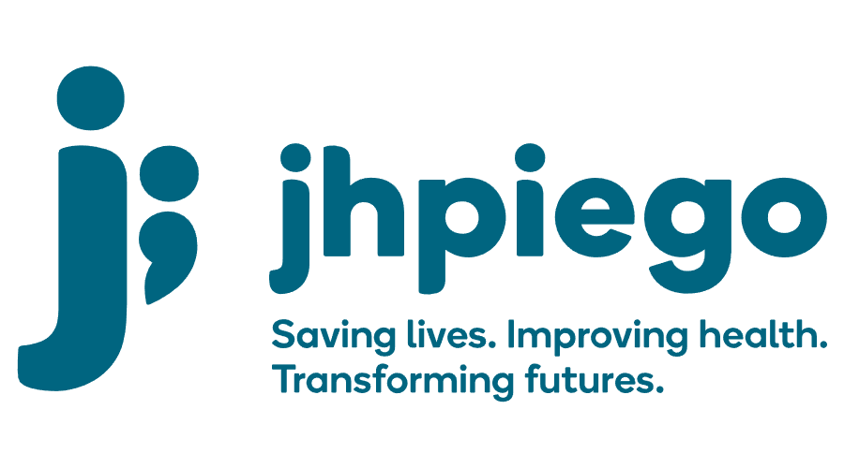

Jhpiego is an international, non-profit health organization affiliated with The Johns Hopkins University. For 40 years and in over 155 countries, Jhpiego has worked to prevent the needless deaths of women and their families.

Jhpiego Corporation has been providing technical support to the Ministries of Health in partner countries across the globe for the past 40 years in a variety of technical areas including cervical cancer treatment and prevention, community health, HIV and AIDS, maternal and newborn health, health workforce capacity development (both pre-service and in-service), family planning, malaria, and IPC/WASH.

The Global Reach II project is a five-year global HRSA-funded project, which started in October, 2021. It employs an iterative approach based on a country’s needs, informed by clients and beneficiaries, targeting high-priority populations and low-coverage and poor-performing areas to achieve HIV epidemic control. In Sierra Leone, Global Reach II works with government and builds local capacity to identify and implement proven solutions where they exist and develop innovative solutions to overcome persistent barriers that affect HIV services. Global Reach II will develop the capacity of the interdisciplinary health workforce to provide quality, client-centered care, ensuring that individuals will be informed and empowered to access services, receive high-quality care, adhere to treatment and remain in care, ultimately contributing to achievement of HIV epidemic control in Sierra Leone.

The following vacant position is available for immediate filling:

Information Technology (IT) Officer

Position Reports to: Finance and Operations Manager
Job Location: Freetown

Job Summary:

Ensures the effective running of the servers and networks at Jhpiego Sierra Leone office under the direction of the Jhpiego ISTS department; providing service desk support to users; and making recommendations for improvement of IT services as required. The IT Officer is a member of Jhpiego's Global IT team, and follows technical direction from the Director of IT.

The nature of this work requires an individual who is service-oriented, organized, and who can interact with diverse end-users and technical staff, prioritize tasks, and resolve technical issues.

Duties and Responsibilities:
- Compliance
- Communicate regularly with the IT team at the Headquarters (Baltimore ISTS) to ensure that the Country Office is following Jhpiego IT regulations and best practices
- In consultation with Baltimore ISTS develop a schedule for key activities and reviews
- Maintain system and configuration change documentation
- Follow Jhpiego IT Service Management processes
- Maintain inventory and assets of office IT hardware and software
- Prepare, document, and communicate system status reports with Baltimore ISTS team

- Backup
- Institute and maintain rigorous and regular back up system for all computers in the office ensuring that all computers are backed up at all times

- Internet
- Manage the relationship with the internet service provider and ensure high-quality internet connectivity
- Monitor Sonic Wall Dashboard and Failover
- Monitor Sonic Points
- Troubleshoot internet connectivity

- User Support
- Install and manage software, including license compliance
- Remedy all issues relating to malware
- Verify that Microsoft Windows and Software Updates are installed regularly
- Maintain Cellphones, desktops and laptops including the replacement of parts
- Provide IT support to staff

- Network
- Maintain network equipment including all switches, wireless access points, firewalls, and
- Riverbed SteeiHead
- Monitor and run network diagnostics to ensure that the network is running smoothly
- Maintain network devices including printers and All-in-One Copiers
- Configure and maintain servers
- Maintain and regularly test power backup systems (e.g. generators, UPSs, battery arrays)

Required Qualification, Knowledge, Skills and Abilities
•Microsoft Certified Technology Specialist (MCTS) certifications for:
    - Windows Server 2003 or higher Network Infrastructure Configuration
    - Windows Server 2003 or higher Applications Infrastructure Configuration
- Cisco Certified Network Associate I Routing & Switching (CCNA R/S) certification
- Experience with Sonic Wall
- Experience with Riverbed SteeiHead technology
- Experience with server hardware from major vendors
- Experience with server operating systems and client/server-based application software, including awareness of version limitations
- Experience with VMware virtualization platform
- Understanding of switches, firewalls, disk caches, filtering systems, access policies and usage of reporting utilities present in the server operating system
- Understanding of the importance of documenting system configuration information
- Highly developed troubleshooting skills and processes
- 2-3 years' experience in similar capacity
- Able to carry loads of SOibs, including servers, printers and computers for physical set up

Qualified persons are required to send their Curriculum Vitae (CV) and application letter to: GH-Recruitments@jhpiego.org

Deadline for the submission of applications: November 12, 2021. Please note that given the likely high volume of applications, only shortlisted candidates will be contacted.

